|  |
| --- |
| **Reimbursement form**  **ERN-RND Annual Meeting 2023**  19 – 20 September 2023 | Leuven, Belgium |
| **Your name:** |
| **Your home address:** |
| **Your institute:** |
| **Bank account details**  Name (of your bank):  Address (of your bank):  IBAN:  SWIFT/BIC: |

According to a Decision of the European Commission we have to reimburse the travel costs based on unit costs depending on the distance between the starting point of your journey (in most cases your home town) and the destination of your travel (the city where the meeting takes place) and the end point of your journey.

Therefore, we will collect different information from you from this year on. There is no need to send the original invoices anymore!

|  |
| --- |
| **Travel information** |
| **Please indicate the name of the city from which you started your trip to Leuven**  City: |
| **Please indicate the date when you started your trip to Leuven**  Date: |
| **Please indicate the name of the city to which you leave from Leuven**  City: |
| **Please indicate the expected date and time of your return from Leuven**  Date:  Time: |

Based on this information, we will calculate and reimburse you the unit costs for travel that have been communicated before. For your information, the costs covered for travel of 400 km or more are given below (return journey):

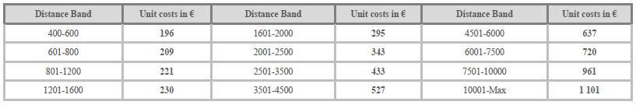

Please return the completed form to

Carola Reinhard

[carola.reinhard@med.uni-tuebingen.de](mailto:carola.reinhard@med.uni-tuebingen.de)

or to Sophie Ripp

[sophie.ripp@med.uni-tuebingen.de](mailto:sophie.ripp@med.uni-tuebingen.de)