|  |
| --- |
| **Reimbursement form ERN-RND** |
| **Event:** ERN-RND Annual Meeting 2025 in Tutzing |
| **Your name:** |
| **Your home address:** |
| **Your institute:** |
| **Bank account details:**  **IBAN:**  **BIC:** |

According to a Decision of the European Commission we have to reimburse the travel costs based on unit costs depending on the distance between the starting point of your journey (in most cases your home town) and the destination of your travel (the city where the meeting takes place) and the end point of your journey.

There is no need to send the original invoices.

|  |
| --- |
| **Travel information** |
| **Please indicate the name of the city from which you started your trip**  From:  To: Tutzing |
| **Please indicate the date when you started your trip**  Date: |
| **Please indicate the name of the city where you will end your trip (if different from the start of the trip)**  City: |
| **Please indicate the date and time of your return**  Date:  Time: |
| **Mean of transportation (train, plane, car):** |

Based on this information, we will calculate and reimburse you the unit costs for travel. For your information, the costs covered for travel are given below (return journey):

Please return the completed form to

Sophie Ripp

[sophie.ripp@med.uni-tuebingen.de](mailto:sophie.ripp@med.uni-tuebingen.de)

**Annex, reimbursement according to unit costs:**

Travel (Decision C(2021)35), see also [here](https://ec.europa.eu/info/funding-tenders/opportunities/docs/2021-2027/common/guidance/additional-information-on-unit-costs-and-contributions_en.pdf).

Travel

For travel of 50-399 km (inside EU countries)

|  |  |  |  |  |  |
| --- | --- | --- | --- | --- | --- |
| **Country** | **Unit costs in €** | **Country** | **Unit costs in €** | **Country** | **Unit costs in €** |
| AT | **60** | ES | **52** | LV | **16** |
| BE | **46** | FI | **36** | NL | **49** |
| BG | **12** | FR | **64** | PL | **20** |
| CZ | **20** | HR | **36** | PT | **40** |
| DE | **64** | HU | **28** | RO | **16** |
| DK | **76** | IE | **36** | SE | **56** |
| EE | **16** | IT | **52** | SI | **27** |
| EL | **36** | LT | **20** | SK | **20** |

For travel of 50-399 km (land-based; between EU countries):

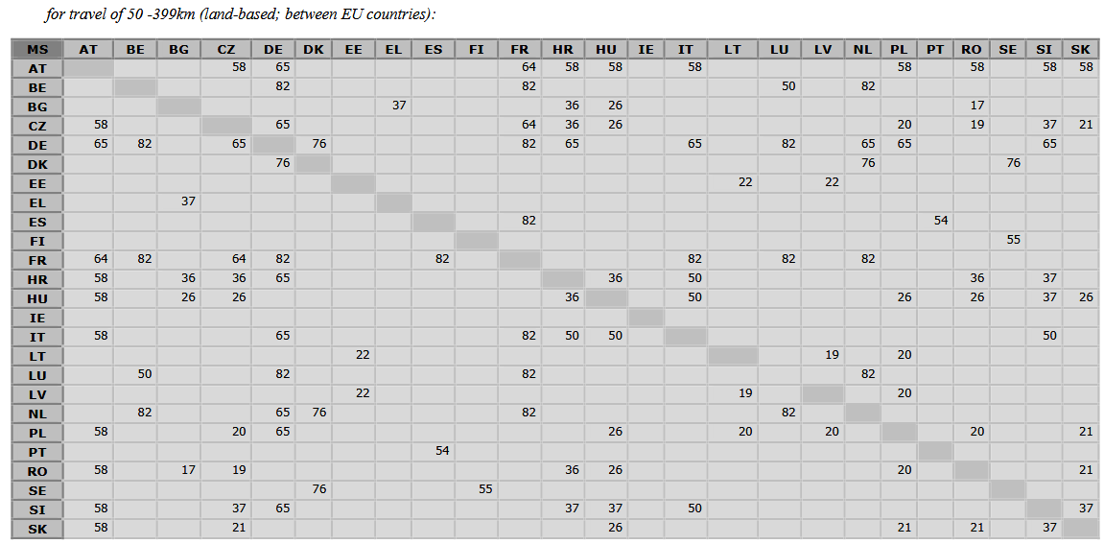

For travel of 400 km or more* (air or rail or combined air/rail):

|  |  |  |  |  |  |
| --- | --- | --- | --- | --- | --- |
| **Distance band** | **Unit costs in €** | **Distance band** | **Unit costs in €** | **Distance band** | **Unit costs in €** |
| 400-600 km | **245** | 1601-2000 | **369** | 4501-6000 | **796** |
| 601-800 | **261** | 2001-2500 | **429** | 6001-7500 | **900** |
| 801-1200 | **276** | 2501-3500 | **541** | 7501-10000 | **1201** |
| 1201-1600 | **288** | 3501-4500 | **659** | 10000-Max | **1376** |